

GRCC

Gloucestershire Village of the Year 2026
Entry Form
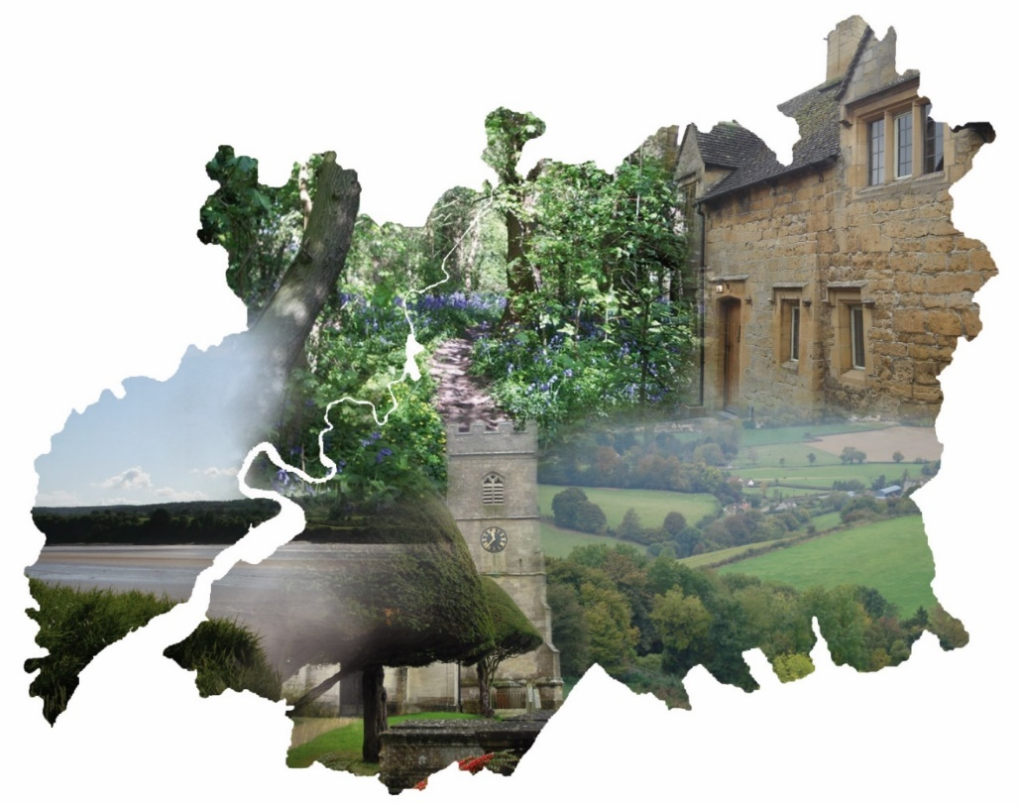

Sponsors:










Supporters:




Introduction
The 2026 GRCC Gloucestershire Village of the Year competition is an opportunity for you to showcase your village, parish, neighbourhood or community. We want to find the places that make the most of local opportunities to sustain or enhance the quality of life of all their residents.
The competition is open to communities in Gloucestershire with a Parish Council or Parish Meeting and a population of under 4,000. It is designed to recognise and celebrate the hard work being carried out in the county.
Cash prizes totalling £15,000 will be awarded to the category winners and runners up, and to an overall winner and runner up. Additional awards may also be presented at the judges’ discretion.
All completed entry forms will automatically be entered into our Grand Prize Draw to win a prize kindly donated by B&Q, to be presented at the awards ceremony in July. The prize is:
- Karcher K3 Pressure Washer
- Kingfisher International Products B.V. FPLM132H-6 132cc Petrol Push Lawnmower
Entry forms are available on the GRCC website www.grcc.org.uk
The closing date for entries is 27 May 2026. Please submit your application form, accompanied by a short 5-minute mobile phone video for each category entered, to info@grcc.org.uk. If you would like any help or advice in completing your form, please contact us on 01452 528491.
Two representatives from each of the shortlisted communities will be invited to the awards ceremony at Highnam Court on the evening of Thursday, 16th July 2026 when the winners will be announced.

GRCC Village of the Year 2026

Guidance notes:
The competition is open to all geographic communities in Gloucestershire with a Parish Council or Parish Meeting and a population of under 4,000. All entries must be supported by their local Parish Council or Parish Meeting.
Please be aware that prizes will not be paid to personal bank accounts – there must be an organisational account (e.g., parish council, neighbourhood partnership, community group) for prize money to be received.
The judging process is in two stages:
- Stage 1 – an assessment by the judging panel of the completed entry forms and accompanying videos
- Stage 2 – a visit to your community by the judges

Completion of the entry form:
Please involve as many members of the community as possible when compiling your entry. The awards are about identifying vibrant communities. We believe that vibrant communities will have the following qualities and characteristics:
Vigilant - looking out for your neighbours and making your community safe
Integrated - involving everyone, taking a whole community approach
Balanced - inclusive of all ages and backgrounds
Resilient - planning for your future and being prepared to deal with emergencies
Active – providing and participating in community activities
Nurturing – supporting and caring for the whole community
Thriving – a community that is successful and has vision
Points to remember:
- Before you start filling in the form, please look at all the categories.
- If you wish to be considered for the overall winner or runner up, you must complete multiple categories.
- You may wish to use bullet points.
- You can provide a short mobile phone video of your project or initiative to support your application if you wish to, but this is optional.
If you have any queries regarding the form, please contact Clare Huckett on 01452 528491 or email info@grcc.org.uk.

Accompanying media:
Please provide up to three suitable digital photographs of your community illustrating one of your activities or initiatives that GRCC may use for publicity purposes.
If you would like to, you can include a short video showcasing a particular project or initiative to enhance your application. Try and capture the thoughts of those involved, ideally including users or intended users of the service or activity where applicable.

Tips for recording videos
- Sound is key, so make sure your environment isn’t too noisy. If you are outside, be careful of wind hitting the microphone.
- A well-lit environment improves the quality of your video. Open the curtains and turn the lights on. If filming outside, do it during the daytime.
Email info@grcc.org.uk when you are ready to send your video(s) and we will send you a Google Drive link to upload to.
Please note, the scoring will be based on the content of the entry form.

The Judging Visit:
GRCC will arrange for the judges to visit your community on a mutually agreed date between 8th and 26th June 2026. The judges will spend up to two hours with members of your community. The visit is your opportunity to expand on your entry form and video(s), and highlight what is special about your community, your successes, and plans for the future. This will not require a formal presentation.
Points to remember:
- Make the most of the judges’ time.
- Include a short ‘tour’ of the community and make use of the village hall (a cup of tea is always welcome!).
- Encourage as many individuals to participate in the visit as you feel is appropriate.
- The judges will not be able to take away any extra material.
Following judging, two representatives from the shortlisted communities will be invited to the awards ceremony at Hignham Court on the evening of Thursday, 16 July 2026 when the category and overall winners will be announced.

Essential Information
District / Borough Council area (delete as applicable): | Cotswold / Forest of Dean / Stroud / Tewkesbury
Name of community:
Name of contact representing the community:
Address:
Postcode:
Email:
Telephone number:
Signature:
Date of completion:
Parish Council / Meeting supporting this application:
Summary of those involved in completing this form
(For example, groups, clubs, older and / or younger people, Parish Council, District Councillors, etc.)

About Your Community
We would like the judges to have a fully rounded picture of your community, so please answer the questions below to give us an idea of the services and facilities available. However, we recognise that some of these things are not within a community’s control, especially Gloucestershire’s smaller parishes and villages. This section will not, therefore, form part of the scoring.

1. Do you have any of the following social, activity, and nature facilities in the village / community?

☐ Village hall / community centre
☐ Playground
☐ Playing field
☐ Indoor sports facilities
☐ Sports pitches
☐ Skateboard ramp
☐ Multi-use Games Area (MUGA)
☐ BMX ramp / track
☐ Nature reserve or wetland
☐ Village pond

2. Does your village / community have any of the following health and wellbeing support / services?

☐ GP practice or visiting GP
☐ Support to stop smoking classes
☐ Falls prevention / Active Ageing / mobility classes
☐ Community Hub
☐ Mental health support groups
☐ Specialist health support groups, e.g., Parkinson’s UK, cancer support groups, etc.

3. Does your village / community have any of these other services or facilities?

☐ Public transport
☐ Community bus/ transport
☐ Post Office
☐ Local shop
☐ Mobile library
☐ Pub
☐ Café
☐ Good mobile phone signal
☐ Good broadband connections
☐ Digital Hub or Drop-in

4. Is your village / community aware of or engaged with these employment, skills, and training services?
☐ Gloucestershire Employment & Skills Hub
☐ Adult Education in Gloucestershire

Category 1: Community-led Health and Wellbeing (including mental health)

Sponsored by: Royal Agricultural University
The winner of this category will receive £2,000, a plaque, and a framed certificate. The runner up will receive £1,000 and a framed certificate.
Health is important to all of us, and we each have an individual responsibility to maintain a healthy lifestyle. The questions set out in this section are designed to find out what types of activities promote physical and / or mental health in your village / community on a regular basis. Tell us how you support everyone in your village / community to stay healthy, active, and well.
Examples could include community-led play schemes, walking groups, good neighbour initiatives, sports clubs, initiatives to improve physical and mental wellbeing, and other ways to encourage engagement and activity (this list is by no means exhaustive). It is advisable, when completing the form, to ensure that the organisers of any of these groups and activities are involved.

Questions
1. Do you have any of the following in the village / community? Please tick:

☐ Good Neighbour scheme
☐ Organised walks
☐ Daytime exercise classes
☐ Evening exercise classes
☐ Sports teams (football, rugby, netball, cricket, etc.)
☐ Running club
☐ Weight management classes
☐ Coffee mornings
☐ Parent and toddler group
☐ Youth club / group
☐ Brownies / Beavers
☐ Guides / Scouts
☐ Gardening group
☐ Hobby groups, e.g., photography, local history, art, etc.
☐ Other

If other, please state:

2. Does your village / community have any of the following local fresh produce schemes? For example, food co-operative, vegetable box scheme, community garden, allotments. Please tick:

☐ Allotments
☐ Community garden
☐ Community orchard
☐ Vegetable box scheme
☐ Food co-operative
☐ Community fridge or pantry
☐ Other

If other, please state:

3. Does your village / community have any active travel groups / initiatives? Please tick:

☐ Cycle paths
☐ Cycling groups
☐ Cycle training for children
☐ Public rights of way / footpath map
☐ Walking bus scheme
☐ Walking groups
☐ Other

If other, please give details:

4. Please tell us about any imaginative or innovative ways in which your village /community is addressing physical and mental health and wellbeing, including tackling social isolation, loneliness, or supporting people with dementia and their carers. Please limit your answer to 400 words.

5. What regular social activities are there for older people in your village / community, and who runs them? For example, lunch club, coffee mornings, etc. Please limit your answer to 400 words.

6. How does your village / community communicate with younger people and what activities / facilities are available to them? Please limit your answer to 400 words.

7. If you win this category, what will you spend the money on? Please limit your answer to 400 words.


Category 2: Climate and Environment (Resilience)

Sponsored by: Freeman Homes
The winner of this category will receive £2,000, a plaque and a framed certificate. The runner up will receive £1,000 and a framed certificate.
The rural district / borough councils in Gloucestershire have declared Climate Emergencies. How does your village / community look at these issues? How does it encourage waste reduction, for example, or sustainable transport initiatives?

Questions
1. Does your village / community have any of the following means of promoting sustainable energy and transport usage? Please tick:

☐ Car share scheme
☐ Community energy schemes / initiatives
☐ Community Speed Watch
☐ Community minibus
☐ Public rights of way / footpath monitoring /maintenance group
☐ Community walking schemes, e.g., walking school bus
☐ Cycle paths / community cycle groups / access to free bicycle maintenance kits
☐ Warm / cool spaces
☐ Other

If other, please give details:

2. Does your village / community have any of the following means of promoting biodiversity and supporting wildlife? Please tick:

☐ Annual seed swap
☐ Annual butterfly count
☐ Bee / bug hotels
☐ Bat / bird nesting boxes
☐ Big Garden Birdwatch
☐ Bird identification walks
☐ Community tree or hedgerow planting projects
☐ Hedgehog awareness, e.g., signs, hedgehog highways
☐ Natural flood management scheme, e.g., leaky woody dams or raingardens
☐ No-mow grass / wild flower meadow areas
☐ Tree walks
☐ Tree Warden
☐ Toad Patrol
☐ Wildlife corridor or garden
☐ Other

If other, please give details:

3. Does your village / community have any of the following means of reducing waste and promoting a circular economy? Please tick:

☐ Boot / garage sales / days when people can put out things they no longer want
☐ Community swap shop / swap-and-share initiative (donate an item to take an item / earn a token for next time, e.g., clothes, tools, toys)
☐ Local social media groups where people can donate items they no longer need / support each other / ask for advice
☐ Second-hand book exchange (e.g., share box, converted telephone box or bus shelter)
☐ Recycling initiative (e.g., TerraCycle)
☐ Repair Café
☐ Annual tidy-up day or litter picking group
☐ Community composting
☐ Surplus Food Redistribution (e.g., via Food Banks or Community Fridges)
☐ Other

If other, please give details:

4. What environmental or community policies does your local Parish / Town Council have, and have they been implemented successfully? Please limit your answer to 400 words.

5. How is your village / community engaging younger people in environmental issues and sustainable action? Please limit your answer to 400 words.

6. Are there any other activities in your village / community that result in reduced carbon footprints or a reduction in waste?
☐ Yes ☐ No
If yes, tell us more; please limit your answer to 400 words.

7. Does your village / community have plans in place to prepare for future emergencies, e.g., community emergency plan covering flooding, heatwave, snow, pandemics? How would you help sustain your village / community in the event of these? Please limit your answer to 400 words.

8. If you win this category, what will you spend the money on? Please limit your answer to 400 words.

These questions will be unscored, but we would like to find out about your community / village’s experiences of how development has had a positive environmental impact:

9. How has your village / community engaged and collaborated with housing associations, developers, and planning bodies to encourage responsible delivery of housing that enhances the local environment? Please tick all that apply:

☐ Biodiversity improvements (e.g., wildlife corridors, native tree planning, wetlands)
☐ Energy-efficient homes (e.g., EPC A-rated, air source heat pumps, solar panels)
☐ Sustainable drainage (e.g., swales, permeable paving, attenuation basins, rainwater harvesting)
☐ Improvements to community facilities (e.g., improving existing facilities, incorporating new indoor or outdoor spaces, footpaths, cycle paths)
☐ Supporting nature-positive design (e.g., bird / bee / bat boxes, hedgehog highways, wildlife corridors, dark skies)
☐ Encouraging low-carbon building practices (e.g., timber frame construction, recycled materials)
☐ Other

If other, please give details limiting your answer to 400 words:

10. Has your village / community supported a new housing development in the last five years?
☐ Yes ☐ No
If yes, how?

☐ Through policy in a Neighbourhood Development Plan
☐ Through a Community-led Housing Scheme
☐ Supporting planning applications for new housing
☐ By engaging proactively with developers to influence sustainable design and community development
☐ Other

If other, please give details limiting your answer to 400 words:


Category 3: Volunteering & Skills in the Community

Sponsored by: Gloucestershire Employment and Skills Hub
The winner of this category will receive £2,000, a plaque, and a framed certificate. The runner up will receive £1,000 and a framed certificate.
Volunteering helps strengthen communities through supporting activities and services, and also enhances the personal wellbeing, skills and mental health of volunteers. It can help people learn new skills and gain valuable experience which can help with employment prospects, build confidence, and provide people with a sense of connection to their community. What opportunities are there for volunteering or for learning new skills in your community?

Questions
1. Does your village / community run any projects or have opportunities to help people learn new skills or brush up on existing skills? Please tick:
☐ Yes ☐ No ☐ Don’t know

If yes, please give details, e.g., the aim of the learning; how, when, and where it is delivered; who benefits from it; why you think it is effective. Please limit your answer to 400 words.

2. Does your village / community provide any opportunities that can provide support to people looking for work? Please tick:
☐ Yes ☐ No ☐ Don’t know
If yes, please give details, e.g., what the opportunities are; who benefits from them; why you think this is effective. Please limit your answer to 400 words.

3. Does your village / community provide people with opportunities to volunteer within your community? Please tick:
☐ Yes ☐ No ☐ Don’t know
If yes, please give details, e.g., what opportunities are available; who benefits from them; why you think this is effective. Please limit your answer to 400 words.

4. Does your village / community have opportunities where older and younger people share work- or skills-related experiences?
☐ Yes ☐ No ☐ Don’t know
If yes, please give details, e.g., what these opportunities are; why you think they are effective. Please limit your answer to 400 words.

5. How does your village / community encourage people to get involved in volunteering opportunities and how do you ensure these are accessible to all? Please limit your answer to 400 words.

6. If you win this category, what will you spend the money on? Please limit your answer to 400 words.

Category 4: Digital


Sponsored by: Cotswold District Council, Stroud District Council, and Tewkesbury Borough Council


The winner of this category will receive £2,000, a plaque, and a framed certificate. The runner up will receive £1,000 and a framed certificate.
The use of technology is changing how services are provided, how communities connect, and how individuals interact. It presents opportunities but also risks leaving behind people who are unable to use it or who lack confidence. How does your community make use of technology, and what sort of support is available to help people who need it?

Questions
1. Does your village / community have any of the following? Please tick all that apply:

☐ Free public Wi-Fi
☐ Device sharing schemes
☐Digital skills training / workshops for residents
☐ Community WhatsApp group
☐ Community Facebook page
☐ Parish Council / community website
☐ Digital newsletter

2. Are digital innovations such as virtual meetings or e-services used to support village governance or local decision-making?
☐ Yes ☐ No
Please explain how – limit your answer to 400 words

3. Does your village / community provide any local digital support for people who need it?
☐ Yes ☐ No
If yes, please give details:

4. Can you share an example of how digital tools or technology have brought your village / community closer together? Please limit your answer to 400 words.

5. What role does digital innovation play in preserving and promoting your village / community’s heritage, culture, or tourism? Please limit your answer to 400 words.

6. What future plans does your village / community have for expanding digital connectivity or adopting new technologies to benefit residents? Please limit your answer to 400 words.

7. If you win this category, what will you spend the money on? Please limit your answer to 400 words.

Additional information

What is it about your community that makes it vibrant and inclusive?
Please highlight 5 things that make your community a special place in which to live, work and play. Please limit your response to 500 words:

Overall Winner & Runner Up: Gloucestershire Village of the Year

Sponsored by: GRCC
In addition to the category winners and runners up, the judges will select one overall winner and runner up. The overall winner will receive £2,000, a plaque, and a framed certificate. The runner up will receive £1,000 and a framed certificate.


High Sheriff’s Young Person’s Overcoming Adversity Award

Sponsored by: The High Sheriff of Gloucestershire
The winner of this category will receive a framed certificate and a £60 Amazon gift card.
Please note, no video is required to accompany this category.
Tell us about a young person (aged up to 21) in your village / community that you feel is special, has overcome challenges in their life, and deserves recognition. Please limit your answer to 400 words.

