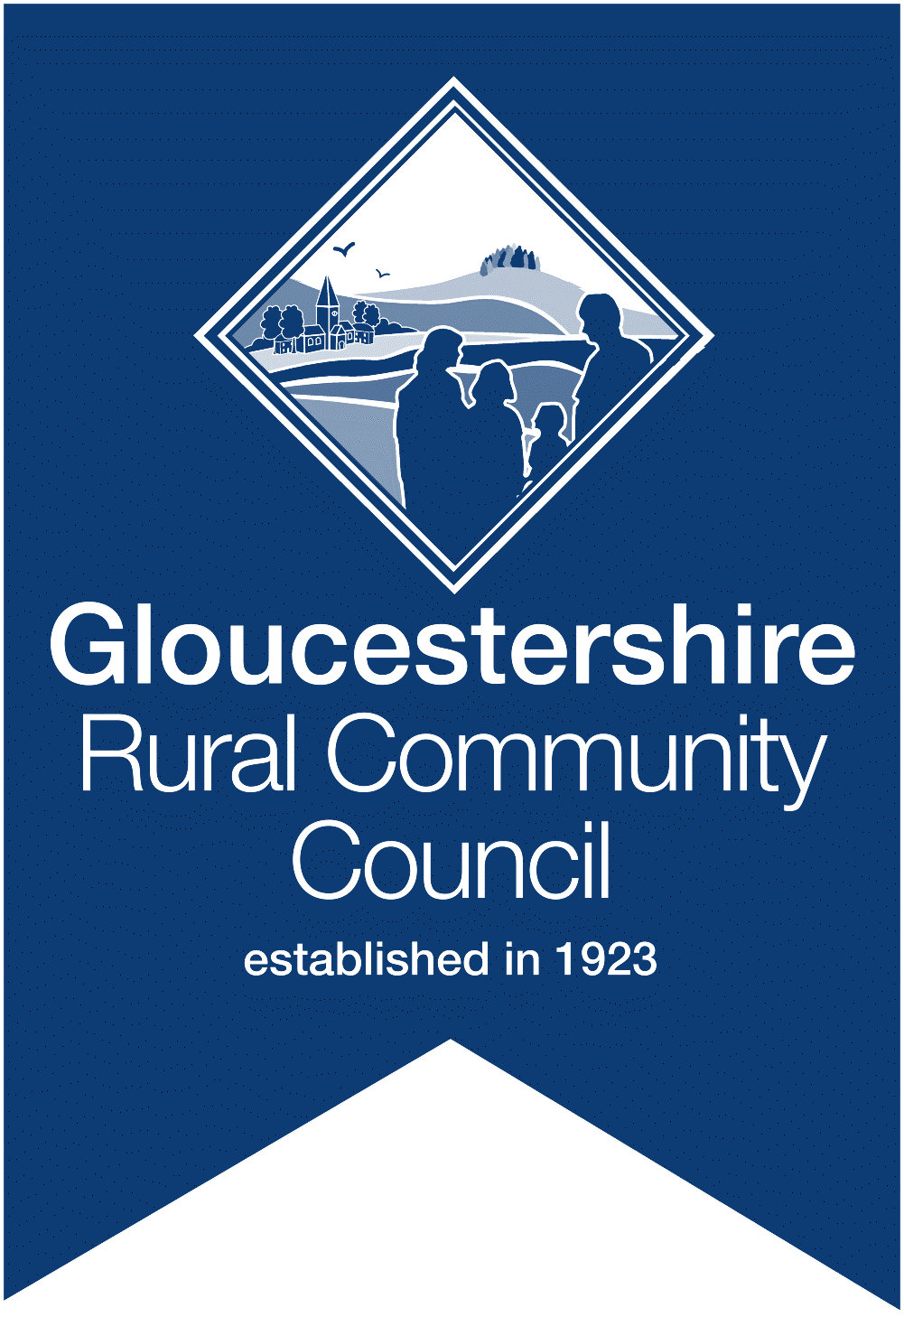
GRCC booking form
Please return this form via email to bookings@grcc.org.uk
or by post to GRCC, Community House, 15 College Green, Gloucester, GL1 2LZ
Event | Neighbourhood Plan Workshop  This is a joint event, organised by CPRE, GAPTC and GRCC
Date | 6th June 2018 10.30am to 3.30pm (refreshments served from 10am)
Venue | Gambier Parry Room (Highnam Community Centre)

The cost of the workshop is £20 per person- as a contribution towards cost of venue, lunch and refreshments. You will be invoiced on receipt of a booking form and payment must be made prior to the event.
Name of attendee
Organisation / community
Contact email address for attendee
Telephone number for attendee
Invoice contact (if different to the above)
Invoice email address (if different to the above)
Postal address (for invoicing purposes)
Special dietary needs (if any)

The venue has a hearing loop and full access to the hall and toilets. Please contact bookings@grcc.org.uk if you have further access needs.

Processing personal data
Personal data will be processed by GRCC according to the Data Protection Act 1998, the General Data Protection Regulations and GRCC’s Data Protection and Confidentiality Policy.
Information you provide will be held, securely, by GRCC for legitimate interests - i.e. for the purposes of administering this event and for sending follow up materials and evaluation information. Booking data will not be shared and it will be deleted within 6 months of the event. If you would like your booking data to be deleted earlier please contact bookings@grcc.org.uk .
GRCC is a charitable company, limited by guarantee. Further information and contact details can be found on www.grcc.org.uk
GRCC runs a number of events during the year and shares information via regular newsletters.
I consent to GRCC sending me details of future events and training via email. Yes ☐ No ☐
If you would like to subscribe to the GRCC e-newsletter mailing list please click here.

Terms and conditions of booking

Your place at the event will be confirmed on receipt of the booking form. It is possible to substitute an alternative delegate on any place booked at no additional cost but please notify GRCC of the change via email prior to 6th June 2018.
Cancellation
Bookings can only be cancelled in writing via post or email.
Cancellations received up to 14 days before event date: Full refund
Cancellations received 7 to 14 days before event date: 50% refund
Cancellations received less than 7 days before event date: No refund
Please ensure you have read, understood and accepted these Terms and Conditions before you place a booking. By placing a booking you will be deemed to have read, understood and accepted them.

GRCC
Community House
15 College Green
Gloucester
GL1 2LZ
Tel: 01452 528491

